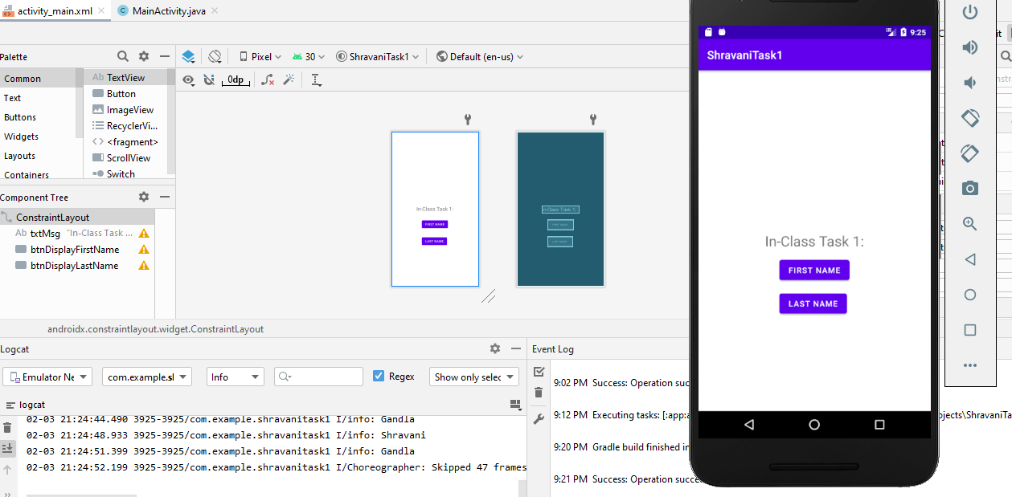

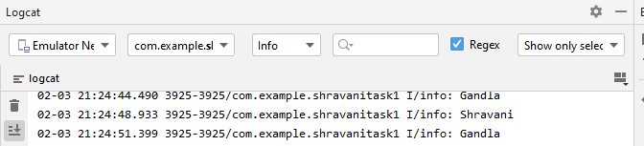

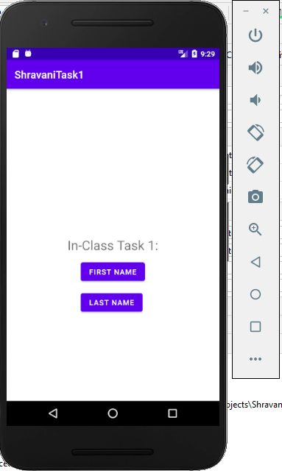

**JAVA CODE :**

package com.example.shravanitask1;  
  
import androidx.appcompat.app.AppCompatActivity;  
  
import android.os.Bundle;  
  
import android.util.Log;  
import android.view.View;  
  
public class MainActivity extends AppCompatActivity {  
  
 @Override  
 protected void onCreate(Bundle savedInstanceState) {  
 super.onCreate(savedInstanceState);  
 setContentView(R.layout.*activity_main*);  
 }  
 public void dispFirstName(View v){  
Log.*i*("info", "Shravani");  
 }  
 public void dispLastName(View v){  
Log.i("info","Gandla");  
 }  
}